Pokhara University

Level: Bachelor | Semester – Fall | Year : 2009
Programme: BE |  | Full Marks : 100
Course: Chemistry |  | Time : 3hrs.

Candidates are required to give their answers in their own words as far as practicable.
The figures in the margin indicate full marks.

Attempt all the questions.

1. | - How does Bohr's theory account for the origin of for H-spectrum? Derive an expression for the radius of an electron moving in first orbit of H-atom. Calculate the wavelength of emitted radiation when an electron jumps so as to form second line in Balmer series of H-spectrum. (R = 1.097×10⁷m⁻¹)  - What do you understand by wave particle duality of matter and radiation? Derive de Broglie's equation and point out that how this equation support the Bohr's postulate for quantization of angular momentum. | 7  8
2. | - Write the buffer mechanism of an acid buffer. A buffer solution containing 0.4 mol lit⁻¹ of CH₃COOH and 0.6 mol lit⁻¹ of CH₃COONa has prepared. What will be the PH of this solution after 0.1mol lit⁻¹ of HCl has been added to the buffer? (Given: Ka = 1.75×10⁻⁵)  - What is Electron Chemical series? Explain its significances. Calculate the emf of the following cell at 25⁰ C.  Zn(a=0.2)/Zn++//Ag+(a=0.1)/Ag  E⁰Ag/Ag+=-0.79V E⁰Zn++/Zn=-0.76V  OR  - Explain Ostwald's dilution law. Discuss its weaknesses. Calculate the pH of buffer solution which is made from 300ml of 0.3M Propanoic acid and 200ml of 0.4M sodium Propanoate. Given that the degree of dissociation for acid is 1.3%.  - What is standard electrode potential? How is electrode potential of Cu- electrode measured experimentally? Calculate the emf of the cell at 27⁰C when the given electrodes are coupled together. Also explain which of the given electrodes acts as anode and why?  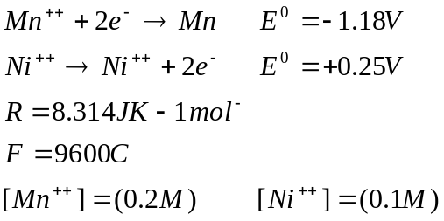 | 7  8
3. | - What is the difference between ionization potential and electron affinity? Why is electron affinity of chorine higher than fluorine?  - Explain following:  - Transition metals are paramagnetic in nature.  - Transition metals has variable valency  - Transition metals ions are coloured | 7  8
4. | - Give the scheme of hybridization in PCl₅ molecule and also predict its geometry.  - What is hydrogen bond? Explain why NH₃ has higher boiling point than PH₃.  - Write the basic assumptions of VBT of covalent bonding. Point out its important limitations. | 5  5  5
5. | - Define hyperconjugation. Pr-alkyl groups are more electron repelling than see-alkyl groups if attached with a multiple bond. Explain.  - Differentiate between Enantiomers and Diasterioumers with examples.  - Write IUPAC name of the following compounds:  - C₆H₅CHO  - CH₃COOC₂H₅  - CH₃-CHBr-CH₂-OH  - .  - CH₃CH₂COOH | 5  5  5
6. | - Explain the mechanism of addition of the HBr to CH₃CH = CH₂ in absence of light and peroxide.  - What is the difference between thermoplastic and thermoplastic and thermosetting plastics? Explain addition polymerization with suitable example.  - Write the mechanism of SN² reaction. | 4  7  4
7. | Write short notes on (Any Two)  - Heisenberg's uncertainty principle  - Green house effect  - Schrodinger's wave equation | 5×2

